電通二乙微處理器實驗 實驗結報

實驗名稱 | Wifi
組別 | 21 | 組員 | 陳乙逢

- 實驗目的
接收wifi訊號
- 實驗步驟

- 程式碼
（1）
#include <LWiFi.h>

#include "MCS.h"

char _lwifi_ssid[] = "I love MCU";

char _lwifi_pass[] = "seikoppp";

MCSDevice mcs("DNXbzGRg", "E5FjPe64CH26Jx7O");

MCSControllerOnOff led("LED_Control");

MCSDisplayOnOff remote("LED");

void setup()

{

Serial.begin(9600);

Serial.println("Connect to Wifi");

while (WiFi.begin(_lwifi_ssid, _lwifi_pass) != WL_CONNECTED) {

Serial.println("Wifi Reconnecting..");

delay(1000);

}

Serial.println("Connect to MCS...");

while (!mcs.connected()) {

Serial.println("MCS Reconnecting..");

mcs.connect();

}

Serial.println("MCS Connected!");

mcs.addChannel(led);

mcs.addChannel(remote);

pinMode(7, OUTPUT);

}

void loop()

{

while (!mcs.connected()) {

mcs.connect();

if (mcs.connected()) {

Serial.println("MCS Reconnect");

}

//mcs.connect();

}

mcs.process(1000);

if (led.value() == 1) {

digitalWrite(7, HIGH);

} else {

digitalWrite(7, LOW);

}

delay(200);

}
（2）
#include <LWiFi.h>

#include "MCS.h"

char _lwifi_ssid[] = "I love MCU";

char _lwifi_pass[] = "seikoppp";

MCSDevice mcs("DgUzyWu2", "yses00FIdIWesDFr");

MCSDisplayInteger Temp("Temp");

void setup()

{

Serial.begin(9600);

Serial.println("Connect to Wifi");

while (WiFi.begin(_lwifi_ssid, _lwifi_pass) != WL_CONNECTED) {

Serial.println("Wifi Reconnecting..");

delay(1000);

}

Serial.println("Connect to MCS...");

while (!mcs.connected()) {

Serial.println("MCS Reconnecting..");

mcs.connect();

}

Serial.println("MCS Connected!");

mcs.addChannel(Temp);

}

void loop()

{

while (!mcs.connected()) {

mcs.connect();

if (mcs.connected()) {

Serial.println("MCS Reconnect");

}

}

mcs.process(1000);

int sensor = analogRead(A0);

Temp.set(sensor);

Serial.println("Add sensor value.");

delay(200);

}

- 實驗結果及分析
接收到wifi訊號得到結果
- 心得討論
更加熟悉wifi使用
- 修正電路圖
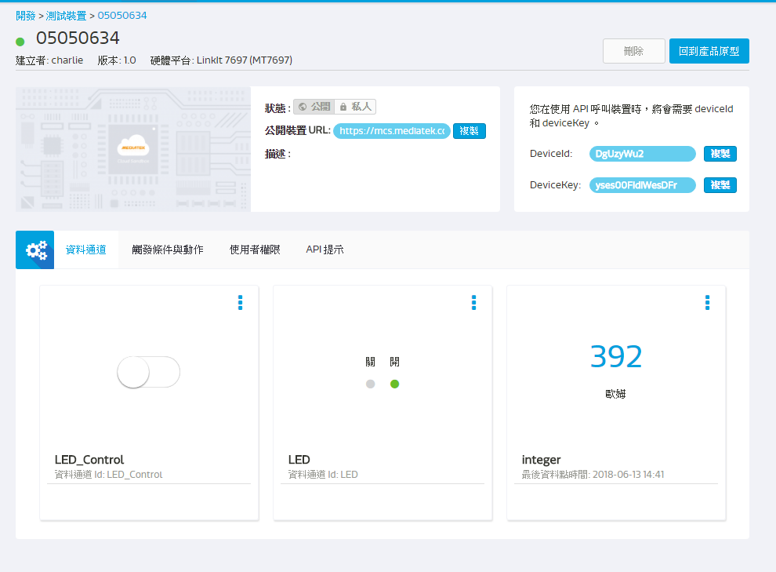
- 修正程式碼

